

LA GRANDEE INTERNATIONAL COLLEGE
Simalchaur, Pokhara Nepal
A Final Project Report
On
“ Food Delivery system”
Submitted to:
LA Grandee International College
Bachelor of Computer Application (BCA) Program
In partial fulfilment of the requirements for the degree of BCA under
Pokhara University
Submitted by:
Aska Godar
Dikshya Chhetri

Introduction
The Food Delivery System that allows customers to order food online from restaurants. It provides an easy way for users to browse menus, place orders, and get food delivered to their location. This system reduces manual work and improves efficiency for both customers and restaurant staff.
In addition, the system offers a user-friendly interface where customers can create accounts, save delivery addresses, and view their order history for future reference. It often includes advanced features such as estimated delivery times.
Overall, the Food Delivery System enhances customer satisfaction by providing convenience, speed, and transparency, while also helping businesses increase their reach, streamline operations, and boost revenue in the competitive food industry.

Aim and Scope

Aim
The main aim of this project is to design and develop a scalable, secure, and user-friendly food delivery system that enables customers to order food online easily while helping local restaurants manage orders efficiently.

Scope
The system will serve three main users:
Customer Interface
- User registration/login (email, phone, OTP)
- Browse restaurants and menus
- Add items to cart and place orders
- Real-time order tracking
- Cash on Delivery
Restaurant Panel
- Manage menu items (Add, Update, Delete)
- View incoming orders
- Update order status (Preparing, Ready, Delivered)
- Sales dashboard and analytics.
Admin Panel
- Manage users and restaurants
- Monitor system activities
- Handle payments
- Resolve disputes

Objectives
The main objective of a Food Delivery System is to connect customers with restaurants and ensure fast, convenient, and efficient delivery of food. It aims to digitize the traditional ordering process, reduce manual effort, and enhance overall user experience for both customers and businesses.
- Simplify Food Ordering Process : The system provides a user-friendly interface where customers can easily browse menus, select food items, and place orders within a few clicks. Features like search options, filters, and “add to cart” make the ordering process quick and hassle-free. This reduces time and effort compared to traditional phone-based ordering.
- Efficient Restaurant Management: It helps restaurants digitally manage their operations, including menu updates, pricing, order handling, and availability of items. Restaurants can track incoming orders in real time, reduce manual errors, and improve service efficiency. This leads to better organization and increased productivity.
- Real-Time Order Tracking: Customers can track their orders live, from preparation to delivery. The system provides status updates such as order placed, preparing, out for delivery, and delivered. This increases transparency and builds trust, as customers always know the progress of their order.
- Enhance Customer Satisfaction: By providing fast service, accurate delivery, and easy ordering, the system improves overall customer satisfaction. Features like reviews, ratings, and feedback allow continuous improvement in service quality.

Study of the Previous System
Analyzing existing food delivery systems in Nepal provides important insights into customer behavior, delivery efficiency, and system limitations, helping in the development of a more localized, reliable, and user-friendly food delivery solution

Anytime Flavours
Anytime Flavours is a local food delivery service that operates 24/7, providing convenient access to food at any time of the day or night. The system mainly relies on a direct communication model, where customers place orders through phone calls or messages. It uses a local delivery network to ensure quick service within the Pokhara area.
Strengths:
- 24/7 service availability
- Fast delivery within local area
- Direct communication with customers (call/message)
- Simple and easy ordering process
- Suitable for non-technical users
- Flexible handling of customer requests
Weaknesses:
• No automated system
• No real-time order tracking
• High chance of human errors
• Limited to small/local area
• No proper digital record of orders

Current Problem and Proposed Solution

Problem Statement
The following issues have been identified in the current food delivery system landscape in Nepal, particularly in regional markets like Pokhara:
- Limited Digital Accessibility for Small Restaurants: Many existing platforms require restaurants to use complex apps or dashboards. Small and local food vendors with limited technical knowledge face difficulties in managing menus, updating items, and handling online orders efficiently.
- Lack of Real-Time Order Tracking: Some local delivery services do not provide live tracking features. Customers are unable to monitor order status, which creates uncertainty and reduces overall trust in the service.
- Lack of Centralized Data and Order Management: Many local systems operate manually without proper data storage. This makes it difficult to track orders, analyze performance, or improve service efficiency over time.

Proposed Solution
The proposed Food Delivery System addresses the identified challenges through the following technical implementations:
Simplified Restaurant Dashboard: To reduce technical complexity, the system provides a user-friendly, mobile-first dashboard for restaurants. It includes simple menu management, easy order notifications, and minimal input requirements, making it accessible for small and local food vendors with limited technical knowledge.
Real-Time Order Tracking System: To improve transparency, the system offers live order tracking, where customers can see the status of their order (placed, preparing, out for delivery, delivered). This enhances user confidence and reduces uncertainty during the delivery process.
Integrated Communication System: To minimize miscommunication, the platform includes in-app messaging or call features between customers, restaurants, and delivery personnel. This ensures clear coordination regarding order details and delivery instructions.

High level requirements
The following requirements outline the detailed functional and non-functional specifications of the Food Delivery System.

Functional Requirements

User Management Module
FR-UM-001: Customer Registration
- System shall allow customers to register using email or phone number.
- System shall verify the email/phone number via a 6-digit OTP (One Time Password).
FR-UM-002: Profile Management
- System shall allow users to update personal information (name, contact details).
- System shall allow users to save multiple delivery addresses.

Restaurant & Menu Module
FR-RM-001: Menu Management
- System shall allow restaurants to Create, Read, Update, and Delete (CRUD) food items.
- System shall support adding images, price, and food descriptions.
FR-RM-002: Food Discovery and Search
- System shall provide a search feature to find food items or restaurants.
- System shall allow filtering by category (e.g., veg, non-veg, fast food), price, and rating.

Order and Delivery Module
FR-OM-001: Cart and Checkout
- System shall allow users to add food items to a cart.
- System shall provide a simple checkout process (Address → Payment → Confirmation).
FR-OM-002: Payment Integration
- System shall support Cash on Delivery (COD) as an alternative method.
FR-OM-003: Order Tracking
- System shall allow users to track order status (Order Placed, Preparing, Out for Delivery, Delivered).
- System shall notify restaurants and delivery personnel upon receiving a new order.

Non- Functional Requirement
NFR-01: Performance
- The system shall load the homepage within 3 seconds on a standard 4G network.
- System shall utilize image optimization (WebP format) to minimize data consumption.
NFR-02: Security
- System shall hash all user passwords using the Bcrypt algorithm before database storage.
- System shall implement JWT (JSON Web Token) for stateless and secure session management.
NFR-03: Scalability
- The backend architecture shall support horizontal scaling to accommodate up to 500 concurrent users.
NFR-04: Usability
- The interface shall be fully responsive and optimized for mobile devices .

Requirement Prioritization Table
Table 1: Requirement Prioritization Table
ID | Requirement Name | Priority | Category
FR-UM-001 | Customer Registration | High (P1) | Core
FR-UM-002 | Profile Management | High (P1) | Core
FR-RM-001 | Menu Management | High (P1) | Core
FR-RM-002 | Food Discovery and Search | Medium(P2) | Usability
FR-OM-001 | Cart and Checkout | High (P1) | Core
FR-OM-002 | Payment (COD) | High (P1) | Financial
FR-OM-003 | Order Tracking | Medium (P2) | Operational
NFR-01 | System Performance | High (P1) | Infrastructure
NFR-02 | System Security | High (P1) | Infrastructure
NFR-03 | Scalability | Medium (P2) | Infrastructure

Design

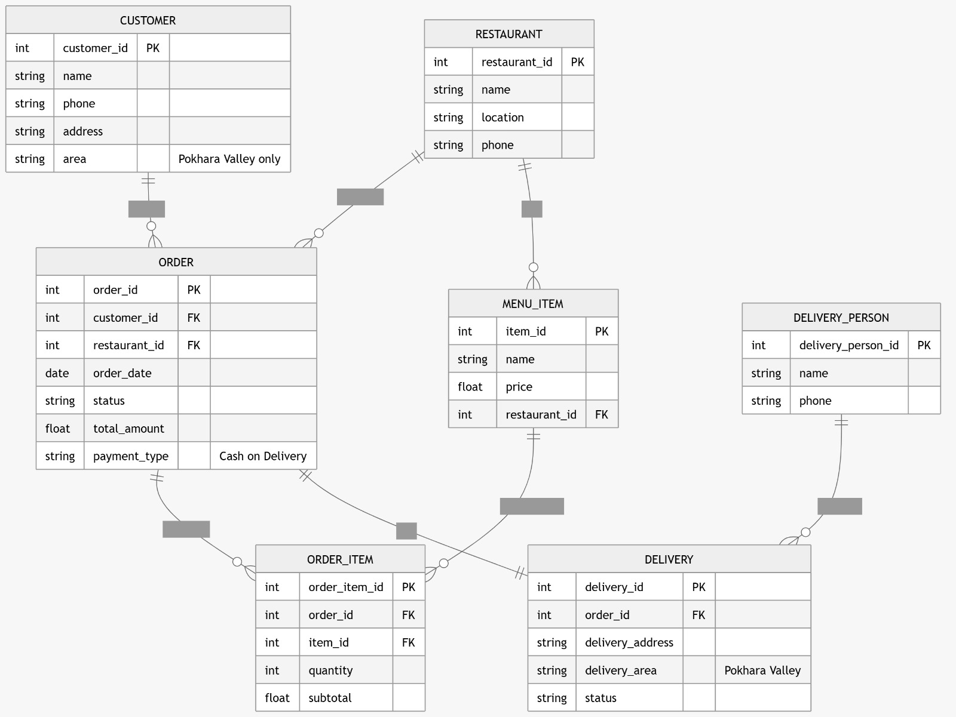
ER Diagram (Entity Diagram)
Figure 1:Food Delivery System ER Diagram

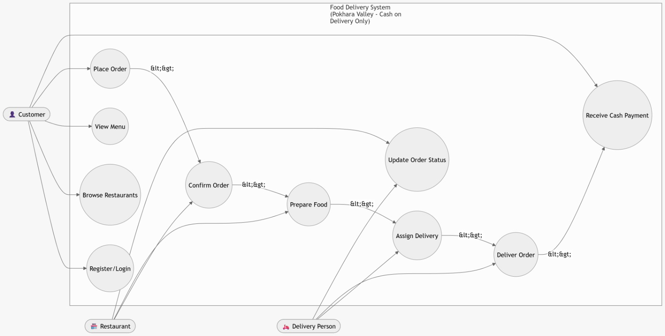
Use Case Diagram
Figure 2:Food Delivery System Use Case Diagram

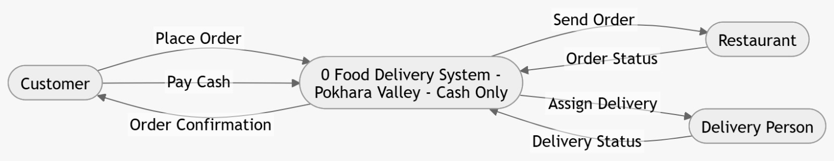
DFD (Data Flow Diagram)
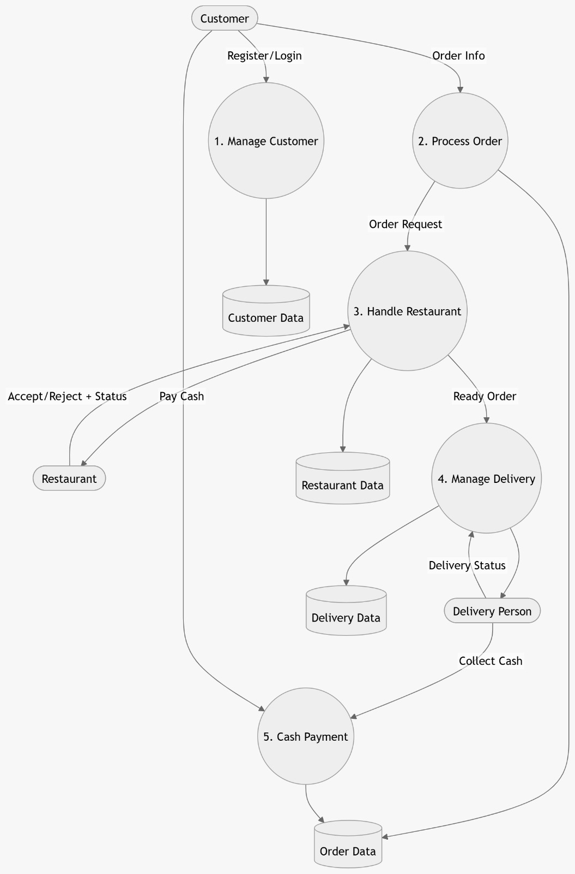
Figure 3:Food Delivery System DFD Level 0
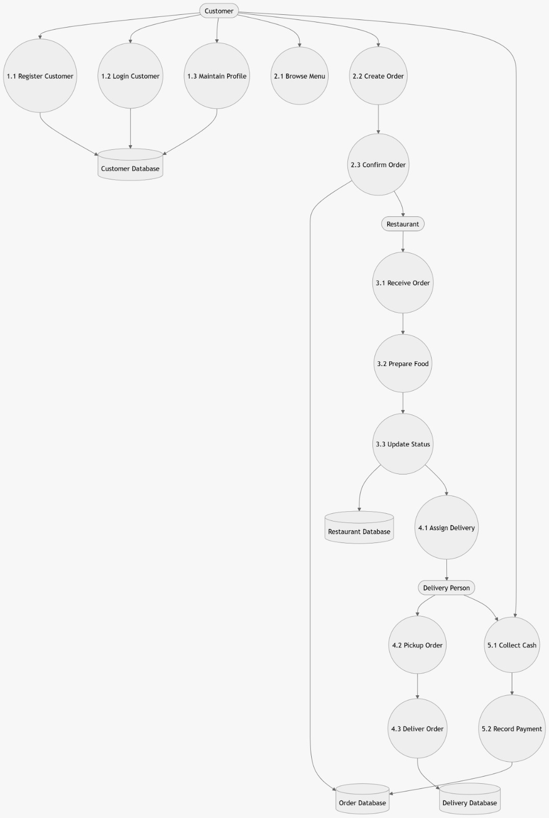
Figure 4: Food Delivery System DFD level 1
Figure 5:Food Delivery System DFD Level 2

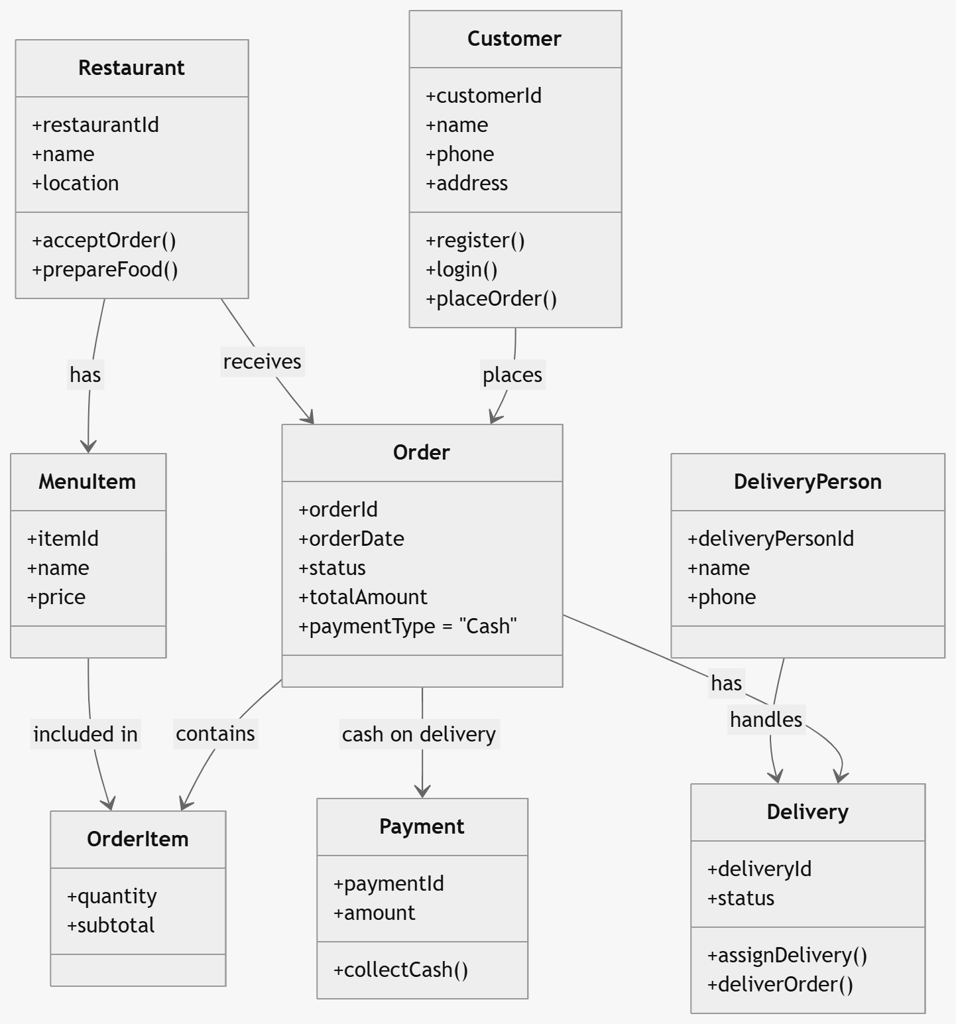
UML
Figure 6:Food Delivery System UML

Detail Budget

Budget Breakdown
Table 2: Estimated Development Cost
Category | Item | Quantity | Cost (NPR) | Total (NPR)
Hosting | Cloud Server (Food Delivery Platform) | 12 Months | 1,100 | 13,200
Domain | .com.np Registration | 1 | Free | 0
Security | SSL Certificate | 1 Year | 2,500 | 2,500
API Fees | SMS Gateway (Order & OTP Alerts) | 5000 SMS | 1.5/SMS | 7,500
Tools | UI Design & Food App Icons | - | 3,000 | 3,000
Delivery | Order Management Setup | - | 2,000 | 2,000
Total |  |  |  | 28,200

Detail Timeline
PROCESS | April |  |  |  |  | May |  |  |  |  | June
 | 1  W  1-3 | 2  W  4-10 | 3  W  11-17 | 4  W  18-24 | 5  W  25-31 | 1  W  1-5 | 2W  6-12 | 3W  13-19 | 4W  20-26 | 5W  27-31 | 1W  1-5 | 2W  6-12 | 3W  13-19 | 4W  20-26 | 5W  27-31
Planning
Design
Develop
mt
Testing
Deployment

Conclusion
The Food Delivery System is an efficient digital solution that connects customers with restaurants, making the process of ordering food simple, fast, and convenient. It allows users to browse menus, place orders, and receive food at their doorstep while enabling restaurants to manage orders effectively. The system improves service quality through features like easy checkout, order tracking, and organized delivery management. By addressing common issues such as delivery delays and lack of coordination, it enhances overall customer satisfaction and operational efficiency. Thus, the food delivery system plays a vital role in modernizing traditional food services and offers strong potential for future improvements and scalability.

References
- Kotler, P., & Keller, K. L. (2016). Marketing Management (15th ed.). Pearson Education.
- Laudon, K. C., & Laudon, J. P. (2020). Management Information Systems: Managing the Digital Firm (16th ed.). Pearson.
- Pressman, R. S. (2014). Software Engineering: A Practitioner’s Approach (8th ed.). McGraw-Hill Education.
- Sommerville, I. (2016). Software Engineering (10th ed.). Pearson Education.
- Foodmandu. (n.d.). Retrieved from https://www.foodmandu.com
- Pathao Food. (n.d.). Retrieved from https://pathao.com/np/food
- Bhojdeals. (n.d.). Retrieved from https://www.bhojdeals.com
- W3Schools. (n.d.). Web Development Tutorials. Retrieved from https://www.w3schools.com
- TutorialsPoint. (n.d.). Software Development Tutorials. Retrieved from https://www.tutorialspoint.com
- Mozilla Developer Network (MDN). (n.d.). Web Docs. Retrieved from https://developer.mozilla.org

